AWS Challenge

Launch one EC2 instance Amazon linux 2

* Install Docker.
* Install Jenkins.
* Install Apache.
* Install Nginx.
* Install Apache Tomcat.

1. Launch one EC2 instance using Amazon linux 2

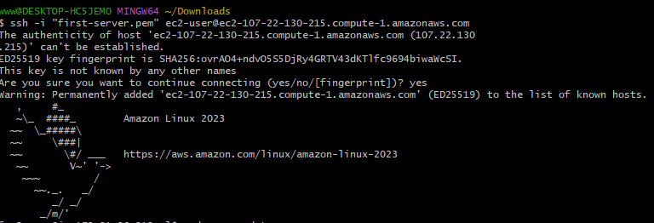

1. Install Docker

Enable & install:

Sudo yum install -y docker

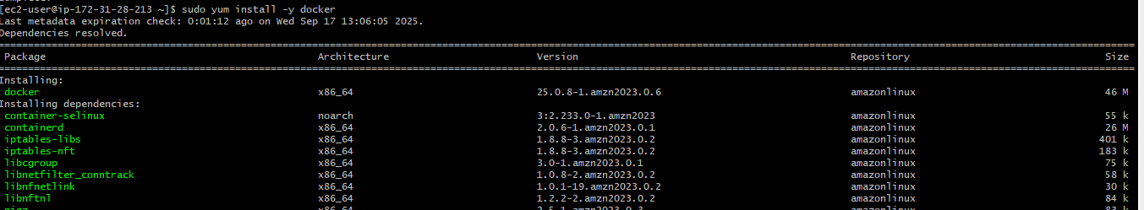



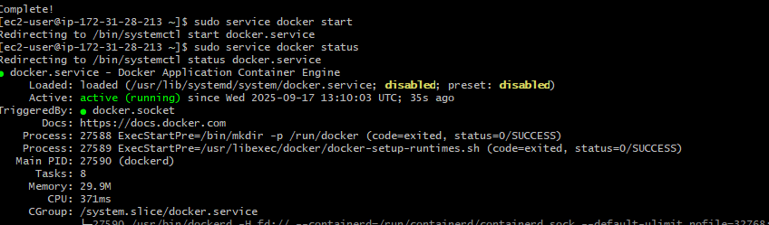

Use this command for checking the version: “docker-version”



1. Install HTTPD (Apache)

Run following commands to install and run HTTPD.

* Sudo yum install httpd -y
* Sudo systemctl start httpd
* Sudo systemctl enable httpd
* Sudo systemctl status httpd

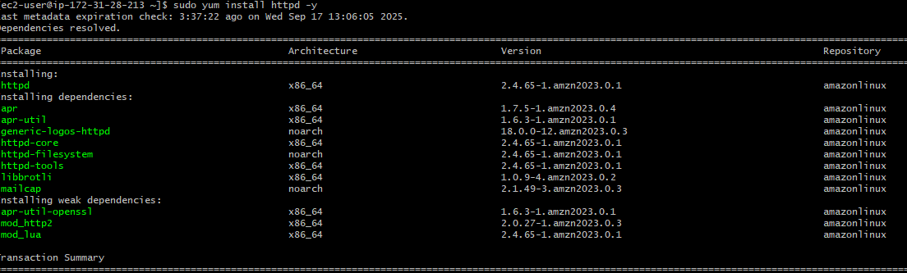

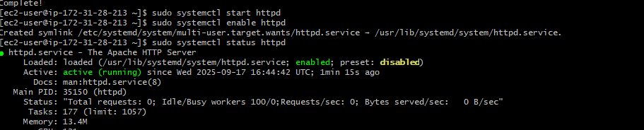

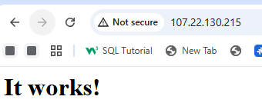

1. Install NGINX

Run sudo yum install nginx -y to install and run NGINX.

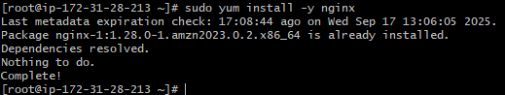

Run systemctl start nginx and systemctl enable nginx to start nginx

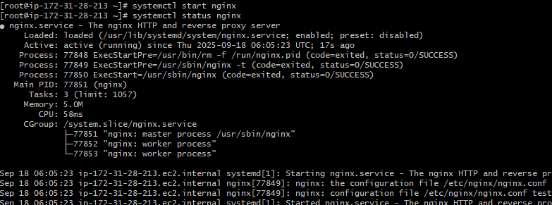

Run public_ip 81 in browser

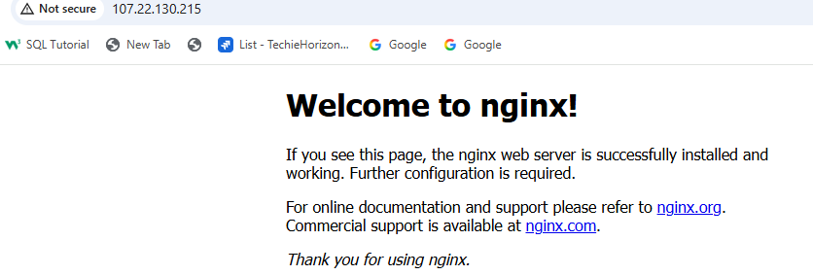

1. Install Apache Tomcat.

* Sudo yum install java
* Sudo wget <https://dlcdn.apache.org/yomcat/tomcat-11/v11.0.11/bin/apache-tomcat-11.0.11.tar.gz>
* Sudo tar -xvzf apache-tomcat-11.0.11tar.gz

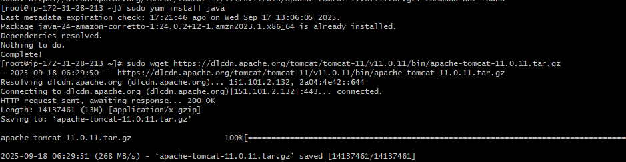

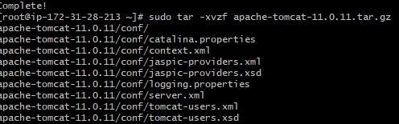

Now go to bin/ directory and run ./startuo.sh to run Apache tomcat

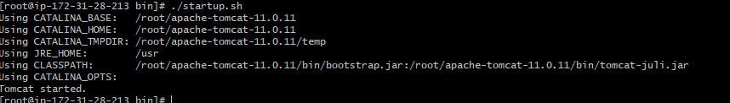

Run public_ip:8080 in browser

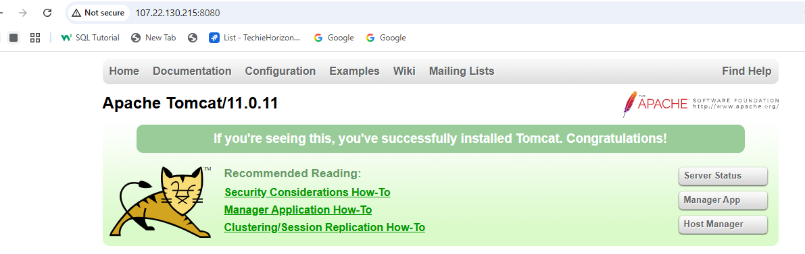

1. Install Jenkins

Run following commands to install Jenkins.

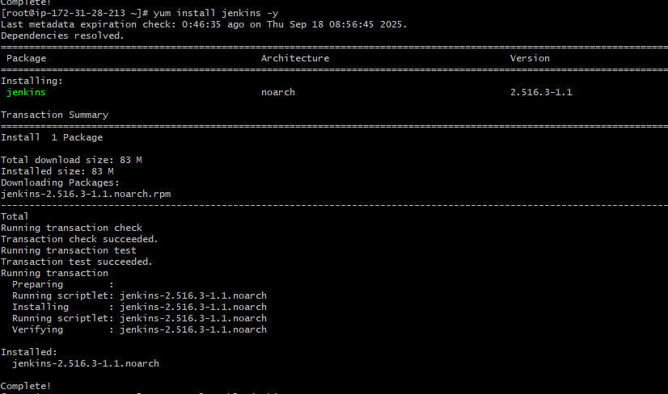

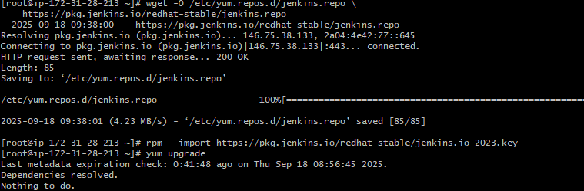

Sudo systemctl status Jenkins

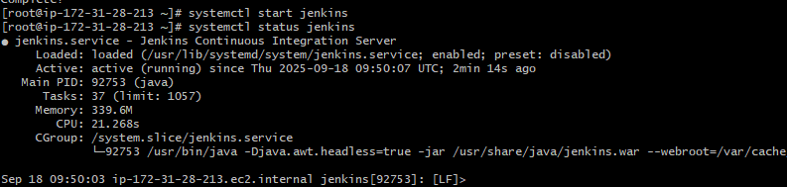

Run public_ip:8080 in your browser and copy the path and give cat path to get password, copy that password and use it in login page

